For First Terminal Examination -2081
Class-10
Subject: Optional Mathematics Course Contents:
1.Algebra: Function
2.Matrix: All
3.Coordinate Geometry: conditions for lines to be parallel and perpendicular
4.Trigonometry: Multiple angles Sub- multiple angles
5.Limit and continuity :all
6. Statistics :all
For Second Terminal Examination -2081
1.Algebra: Polynomials, Function
2.Coordinate Geometry: angle between two lines, pair of straight lines,
3.Trigonometry: transformation of trigonometric ratio, Conditional trigonometric identities
4.Vectors: all
5. Limit and continuity: all
6. Statistics: all
7. Matrix:all
For Third Terminal Examination-2081 Course Contents
- Algebra: sequence and series.
- Coordinate: conic section, circle
- linear programming problems.
- Quadratic equation and graphs.
- Limit and continuity.
- Trigonometry: * Solution of trigonometric equation
- Height and distance
- Transformation: All
- Revision all chapter

EMBOCS NAWALPARASI
Specification Grid for First Terminal Examination-2081
S. N | Contents | Topic | K | U | A | H. A | Total number of Questions | Total mark
1 | Algebra | * Function | 2 | 2 | 2 | 1 | 7 | 16
2 | Matrix | all | 1 | 1 | 1 |  | 3 | 6
3. | *Coordinate Geometry | conditions for lines to be parallel and perpendicular | 1 |  |  |  |  | 1
4 | Trigonometry | - Multiple angle  - Sub – multiple angle | 2 | 2 | 3 | - | 7 | 15
5. | Statistics | All |  | 1 | 2 |  | 3 | 8
6. | Limit & continuity | All | 1 |  | 1 |  | 2 | 4
 |  | Total mark | 7 | 6 | 9 | 1 | 22 | 50

EMBOCS NAWALPARASI
Specification Grid for Second Terminal Examination-2081

S. N | Contents | Topic | K | U | A | H. A | Total number of Questions | Total mark
1 | Algebra | - Function  - Polynomials | 1 | 1 | 1 | 1 | 4 | 10
2 | Matrix | all | 1 | 1 | 1 |  | 3 | 6
3. | Coordinate Geometry | all | 1 | 1 | 1 | 1 | 4 | 10
4 | Trigonometry | - Multiple angle  - Sub – multiple angle  - Transformation of Trigonometric ratio  - Conditional trigonometric identities | 2 | 2 | 1 |  | 6 | 9
5. | Vectors | - Scalar product  - Vector Geometry | 1 | 1 |  |  | 2 | 3
6 | statistics | all |  | 1 | 2 |  | 3 | 8
7. | Limit & continuity | all | 1 |  | 1 |  | 2 | 4
Total |  |  | 7 | 7 | 7 | 2 | 24 | 50
Marks |  |  | 7 | 14 | 21 | 8 |  | 50

EMBOCS NAWALPARASI
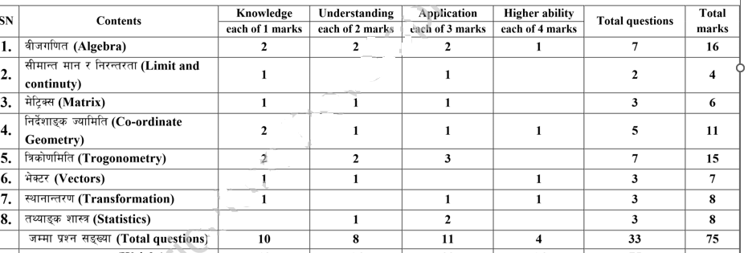
Specification Grid for Third Terminal Examination-2081

EMBOCS NAWALPARASI
Model Questions for First Terminal Examination -2081
Sub: Opt : Math Time FM:50
Class:10 Group A 7x1=6

1a. Define trigonometric function.
b) What is the maximum value of y=sinx.
2a) Write in sentence $\frac{lim}{x→a+}$ f(x).
b) Write the condition of two lines parallel.
3. a) Define singular matrix.
b) Express cos2A in term cosA.
4a) Write the formula to find sin3A.
Group B 6x2=12
5a.In the f= {(1, 2) ,(2, 3) , (3, 4) } and g= (2, a), (4, c) , (3, b) , then show the composite function gof in arrow diagram and find it in ordered pair form.
b) If F(x)=8x+7 then find the value of fof(x) and fof(-2)
6a)If matrix A=$[\begin{matrix}3 & 5 \\ 1 & 2\end{matrix}]$ Find the value of A^{-1.}
b) prove that: $\frac{sin2A-sinA}{1-cosA+cos2A}=tanA$.
7a) IF sinA=$\frac{1}{2}$ (m+$\frac{1}{m}$) then prove that: cos2A= -$\frac{1}{2}$ (m²+$\frac{1}{m^{2}}$).
b) In a group data the quartile deviation and its Coefficient are 15 and $\frac{3}{7}$ respectively find first quartile.

Group C 9x3=27
8.IF f(x)=4x+5 , fog(x)=8x+17, find the value of g⁻¹(7)
9. If f(x)=2x-5 and g(x)=3x+1 are two function then find f⁻¹⁻(x) and g⁻¹(x).
10.A real value function f:R$→R$ is Defined by f(x) = 2x + 3
i) find the value of f(x) at x= 4.9, 4.99, 4.999.
ii) find the value of f(5)
iii) Is this function continuous at x = 5.
11. Solve by cramers method: 8x+11=3y and 6y-15=-2x+11
12. prove that: Tan(45$°$+A)=sec2A+tan2A
13. prove that : $\frac{1}{sin10°}-\frac{\sqrt{3}}{cos10°}=4$
14. prove that: 4cos³20$°$+4sin³10$°=3(cos20°+sin10°)$
15. . Calculate the mean deviation from the median of the given data
x | 0-10 | 10-20 | 20-30 | 30-40 | 40-50
f | 2 | 3 | 5 | 4 | 6
16. Calculate the standard deviation from the given data.

Class interval | 0-4 | 4-8 | 8-12 | 12-16 | 16-20
Frequency | 10 | 8 | 12 | 6 | 4

Group D 1x4=4
17. Two functions are f(x)=$\frac{2x+5}{8}$ and g(x)=3x-4. If (fog)⁻¹(x) is an identity function, find the value of x.

THE END

EMBOCS NAWALPARASI
Model Questions for Secondary Terminal Examination -2081
Sub: Opt : Math Time FM:50
Class:10 Group A 7x1=6

1a)Define identity function.
b) Write a condition to be a continuous for a function.
2a) If matrix A=($\begin{matrix}3 & 5 \\ 1 & 2\end{matrix})$ find A⁻¹.
3a) If $θ$ be the angle between the two straight lines whose equations are as
y=m1 x + c1 and y = m2 x + c2 , then find the value of tan$θ$.
b) The slopes of two straight lines L1 and L2 are M1 and M2 respectively. write the condition of parallelism of lines.
4a) Express sinA in term of tan $\frac{A}{2}$.
b) Write cosx+cosy into product form.
Group B 7x2=14
5a) If f(x)=$\frac{2x-3}{5}$, Find the value of f⁻¹($\frac{1}{5}).$
b) Find the obtuse angle between the lines 2x-y+3=0 and x-3y+4=0.
6a)Find the value of D₁ and D₂ from the given equation y=2x, x+2y=10 by cramers rule.
b) prove that: $\frac{sinθ+sin\frac{θ}{2}}{1+cosθ+cos{θ/}_{2}}$= tan$\frac{θ}{2}$.
7a) Find the value of sin75$°-sin15°.$
b )The position vectors of A and B are $\overset{→}{7i}+\overset{→}{2j}$ and $\overset{→}{3i}$ - $\overset{→}{4j}$ respectively. If the point P is the midpoint of line AB, find the position vectors of point P.
8a) In a data , the first quartile and quartile deviation are 17.5 and 20 respectively. Find the third quartile and coefficient of quartile deviation.
Group C 7x3=21
9. If f(x)=2x-4, then prove that (fof⁻¹)x is an identitity function.
10, If f(x)=$\left\{\begin{aligned}3x+5 x<3 \\ 6x-4 x≥3\end{aligned}\right.$
- For x=2.9999, find the value of f(x)
- For x=3.0001 find the value of f(x)
- Is the function f(x) continuous at x=3.give reason
11. Prove that: 2cos4A+1= (2cosA-1) (2cosA+1) (2cos2A-1)
12. Solve the equation by matrix method. 2x-3y=7and 4y-3x= -1
13. Find the equation of a pair of line through (2,5) and perpendicular to the line 5x+2y=7
14. . Calculate the mean deviation from the mean of the given data
x | 0-15 | 15-30 | 30-45 | 45-60 | 60-75
f | 2 | 7 | 10 | 6 | 5
15. Calculate the standard deviation from the given data.

Class interval | 0-4 | 4-8 | 8-12 | 12-16 | 16-20
Frequency | 12 | 10 | 8 | 5 | 15

Group D 4x2=8
16.Find the equation of straight line passing through the point (3,2) and making angle 0f 45$° with line x-2y-3=0$
17. Solve: y³-19y-30=0
***THE END****

EMBOCS NAWALPARASI
Model Questions for Third Terminal Examination -2081
Sub: Opt : Math Time FM:75
Class:10 Group A 10x1=10
